Quantitative Analysis

In recent years, the Sri Lankan rupee has fluctuated unusually, in some cases losing up to 30% of its value against the US dollar. The Sri Lankan economy has been significantly impacted by this volatility, which has increased the cost of living for common people and made it difficult for corporations to plan and invest.

Quantitative analysis will be used in this section to look at what is causing the exceptional volatility of the Sri Lankan currency. The Section will also look into a variety of methods for reducing this volatility.

A number of data sources, including historical exchange rate data, economic data, and market sentiment data, will be used in the quantitative study. The factors most closely linked to the volatility of the Sri Lankan rupee will be found using a range of statistical methodologies in the study.

01. Hypothesis:

Research Question: Strategies to Mitigate Unusual Volatility of Exchange Rates in Sri Lanka

Hypothesis:

Hypothesis 1:

* **Null Hypothesis (H0):** Exchange rates do not significantly depend on inflation rate, interest rate, GDP growth, unemployment rate, industrial production, trade balance data, remittance data, and share market movements.
* **Alternative Hypothesis (Ha):** Exchange rates significantly depend on at least one of the independent variables (inflation rate, interest rate, GDP growth, unemployment rate, industrial production, trade balance data, remittance data, share market movements).

Hypothesis 2:

* **Null Hypothesis (H0):** The individual coefficients of all independent variables (inflation rate, interest rate, GDP growth, unemployment rate, industrial production, trade balance data, remittance data, share market movements) in the regression model are zero.
* **Alternative Hypothesis (Ha):** At least one of the individual coefficients of the independent variables is not equal to zero, indicating that it has a significant effect on exchange rates.

Hypothesis 3:

* **Null Hypothesis (H0):** The residuals (errors) of the regression model are normally distributed and exhibit constant variance (homoscedasticity).
* **Alternative Hypothesis (Ha):** The residuals of the regression model do not follow a normal distribution, and/or there is heteroscedasticity, indicating that the model may not be the best fit for the data

02. Data Cleaning

Any quantitative study is built on data, and the validity and dependability of our results depend greatly on the quality of that data. In this study, we'll start by talking about the vital process of data cleaning. To maintain our dataset's accuracy and integrity, data cleaning entails locating and fixing discrepancies, errors, and outliers. By carrying out this crucial step, we hope to create a trustworthy and clean dataset that will be the foundation for our quantitative examination of methods for reducing exchange rate volatility in Sri Lanka.

**Missing values:**

There are no missing values in the dataset under study. The dataset's integrity and dependability for further analysis and interpretation are ensured by the presence of genuine and complete data for all variables and observations. The lack of missing values makes data cleaning easier and makes it possible to conduct a basic and reliable quantitative analysis.

**Outlier analyzing:**

We will carefully examine any potential outliers in the dataset as part of our quantitative analysis. Data points known as outliers dramatically differ from the majority of observations and can affect the results of our study. In order to evaluate their influence on our findings, it is crucial to recognize and comprehend these outliers. We will identify and assess outliers using statistical methods and visual representations to determine whether they are actual anomalies or incorrect data.

Visual Inspection

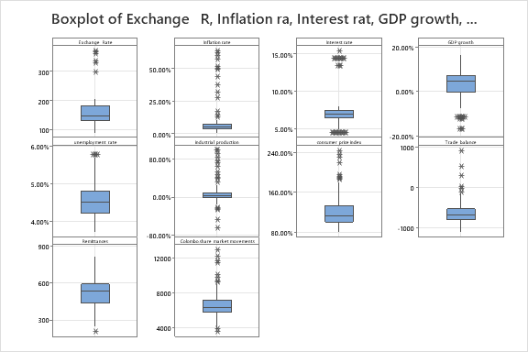

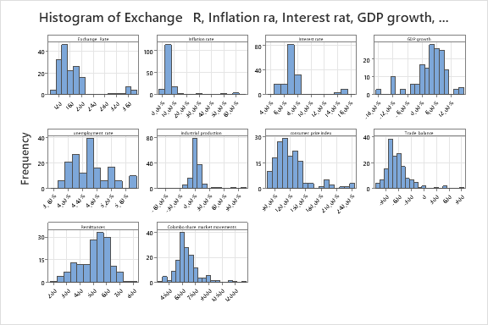

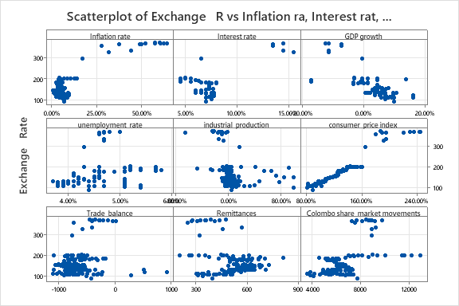

The above graphics make it quite evident how the outliers and variable spreads are distributed throughout the data set. We are therefore aware that our data collection contains some outliers, the majority of which occurred during the crisis in 2022–2023.

The R squared values of the regression models with and without outliers were then examined. R squared value is the most important factor in quantitative analysis (Regression model). Because of this, the R squared value might be used to determine the effective from the outliers.

**Model Summary (With outliers)**

|  |  |  |  |
| --- | --- | --- | --- |
| **S** | **R-sq** | **R-sq(adj)** | **R-sq(pred)** |
| 13.9719 | 95.71% | 95.54% | 94.56% |
|  |  |  |  |

**Model Summary (With-out outliers)**

|  |  |  |  |
| --- | --- | --- | --- |
| **S** | **R-sq** | **R-sq(adj)** | **R-sq(pred)** |
| 7.93436 | 95.11% | 94.90% | 92.79% |

**Regression Equation**

|  |  |  |
| --- | --- | --- |
| Exchange   Rate | = | -54.6 + 82.2 Inflation rate + 143.8 Interest rate + 499 unemployment  rate + 170.26 consumer  price index - 0.01745 Remittances - 0.002334 Colombo share  market movements |

Removed variables

Exchange Rate / GDP growth / industrial production / Trade balance

Assumptions Check

Linearity

* Assumption: The relationship between the dependent and independent variables should be linear.
* Check: You can create a scatterplot of the dependent variable against each independent variable separately to assess linearity. In Minitab, go to "Graph" > "Scatterplot."

Independence of Errors

* Assumption: The residuals (the differences between observed and predicted values) should be independent of each other.
* Check: After running the regression analysis, you can plot the residuals against the predicted values or time to check for patterns or autocorrelation. In Minitab, go to "Graph" > "Residuals Plot."

Homoscedasticity (Constant Variance)

* Assumption: The variance of the residuals should be constant across all levels of the independent variables.
* Check: Create a scatterplot of the residuals against the predicted values. If the spread of points in the plot is roughly constant, homoscedasticity is met. In Minitab, go to "Graph" > "Residuals Plot" and choose "Predicted Values" as the X-axis.

Normality of Residuals

* Assumption: The residuals should follow a normal distribution.
* Check: You can create a histogram or a normal probability plot of the residuals to assess normality. In Minitab, go to "Graph" > "Histogram" or "Normal Probability Plot."

Multicollinearity

* Assumption: Independent variables should not be highly correlated with each other.
* Check: Calculate the Variance Inflation Factor (VIF) for each independent variable. High VIF values (typically above 10) indicate multicollinearity. In Minitab, you can use the "Regression" > "General Regression" > "VIF" option.

No Perfect Multicollinearity

* Assumption: There should be no perfect linear relationship between independent variables.
* Check: Examine the correlation matrix or perform pairwise correlation tests for the independent variables to detect perfect multicollinearity.

**Hypothesis Analyzing**

Hypothesis 1:

* **Null Hypothesis (H0):** Exchange rates do not significantly depend on inflation rate, interest rate, GDP growth, unemployment rate, industrial production, trade balance data, remittance data, and share market movements.
* **Alternative Hypothesis (Ha):** Exchange rates significantly depend on at least one of the independent variables (inflation rate, interest rate, GDP growth, unemployment rate, industrial production, trade balance data, remittance data, share market movements).

**Use p value of the model and it is less than 0.05, so we reject H0;**

**β 1 ≠ 0; β 2 ≠ 0; β 3 ≠ 0; β 4 ≠ 0; β 5 ≠ 0; β 6 ≠ 0;**

(Exchange rates significantly depend on at least one of the independent variables (inflation rate, interest rate, unemployment rate, consumer price index, industrial production, remittance data, share market movements)

Hypothesis 2:

* **Null Hypothesis (H0):** The model as a whole is not a good fit for the data, meaning none of the independent variables are useful in predicting the dependent variable.
* **Alternative Hypothesis (H1):** The model as a whole is a good fit for the data, suggesting that at least one of the independent variables is useful in predicting the dependent variable.

**Use ANOVA table p value and, residual plot and normal probability plot to get conclusion.**

Hypothesis 3:

* **Null Hypothesis (H0):** The residuals (errors) of the regression model are normally distributed and exhibit constant variance (homoscedasticity).
* **Alternative Hypothesis (Ha):** The residuals of the regression model do not follow a normal distribution, and/or there is heteroscedasticity, indicating that the model may not be the best fit for the data.

